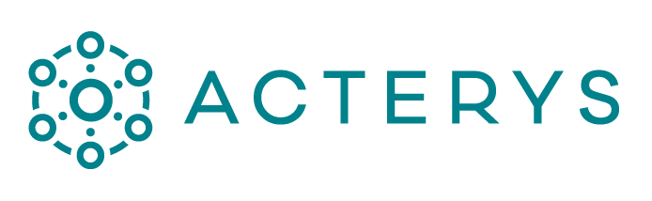

Sydney • Chicago • Munich

acterys.com | info@acterys.com | ABN 47 106 084 413  
• Asia Pacific + 61 1300 00 7256

• Europe +43 89 211 29 798

• North America +1 888-484-8821

Board Report

Copyright © Managility Pty Ltd 2022. All rights reserved. No part of the material protected by this copyright may be reproduced, or utilised in any form or by any means, electronic or mechanical, including photocopying, recording, broadcasting or by any other information storage and retrieval system, without permission in writing from Managility Pty Ltd. All other trademarks referenced are the trademark, service mark or registered trademark of their respective holders.

# Executive Summary

In 2020 we had total revenues of **$6,305.17.**

This was a very positive outcome compared to the lates forecasts and driven predominantly by online marketing campaigns in Q4.